Lab_1_part_II
16. Grand your colleagues a collective directory called /opt/research, where they can store generated research results. Only members of group profs and grads should be able to create new files in the directory, and new file should have the following properties: the directory should be owned by root new files should be group owned by group grads group profs should automatically have read/write access to new files group interns should automatically have read only access to new files other users should not be able to access the directory and its contents at all.

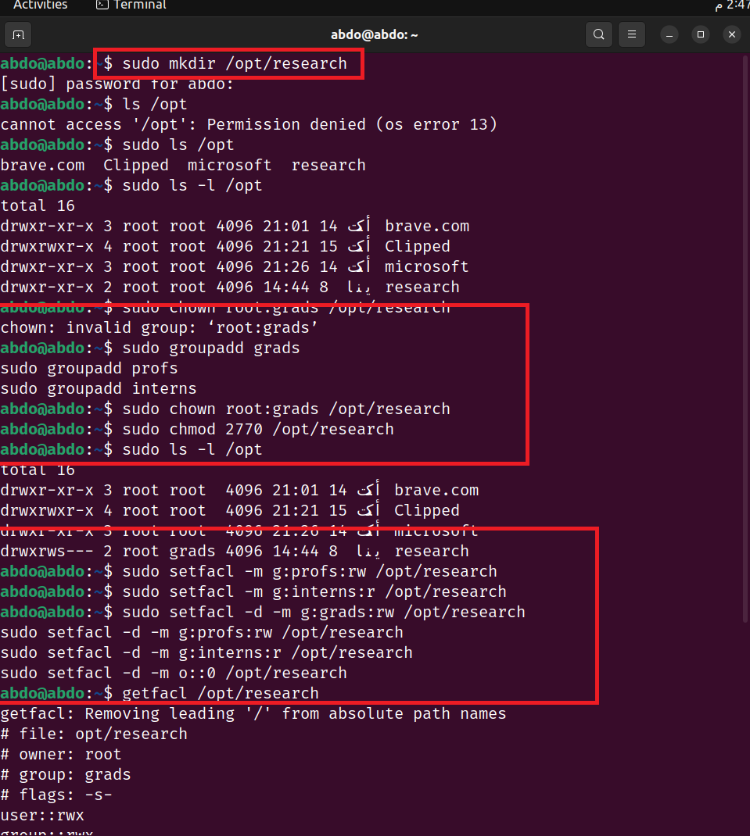

17. Display your MAC address by 2 different ways.
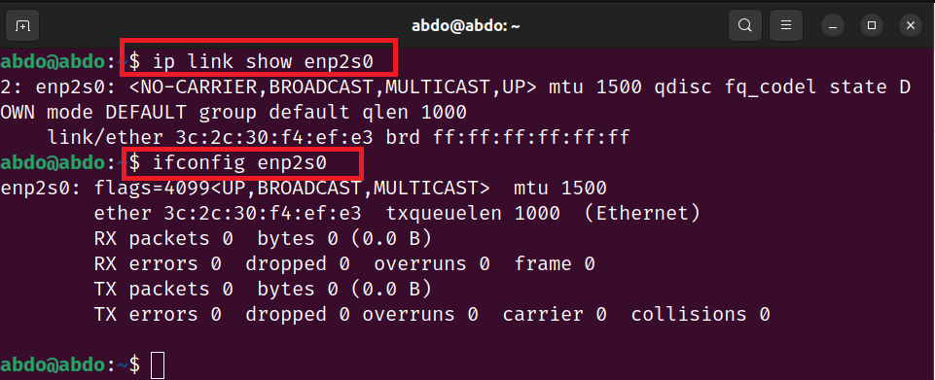

18. Display the network settings of all active interfaces.
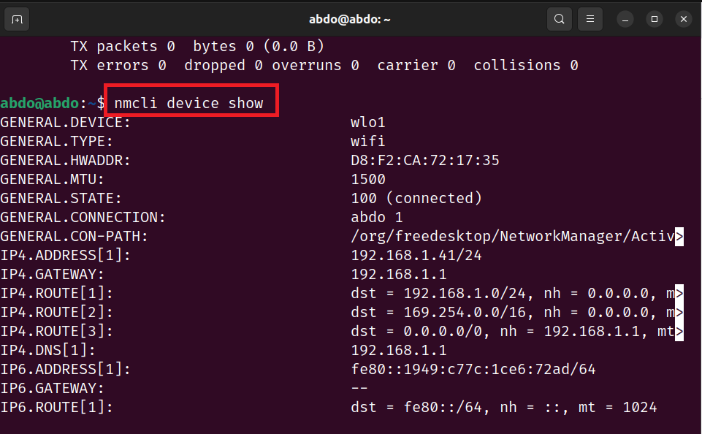
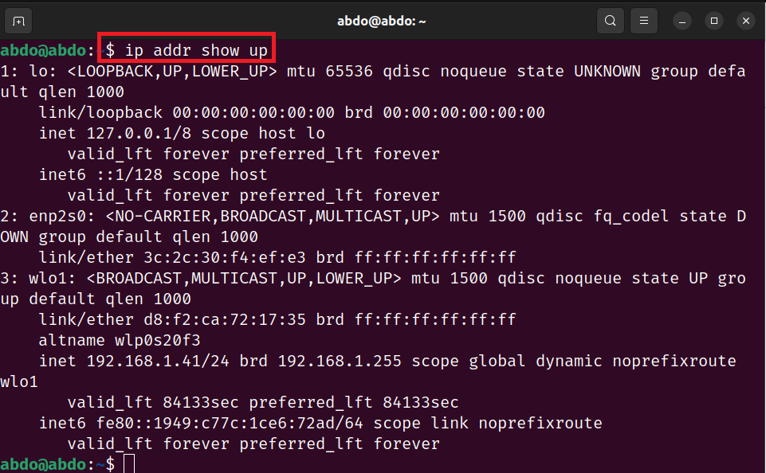

19. Display the network setting of all interfaces both active inactive.

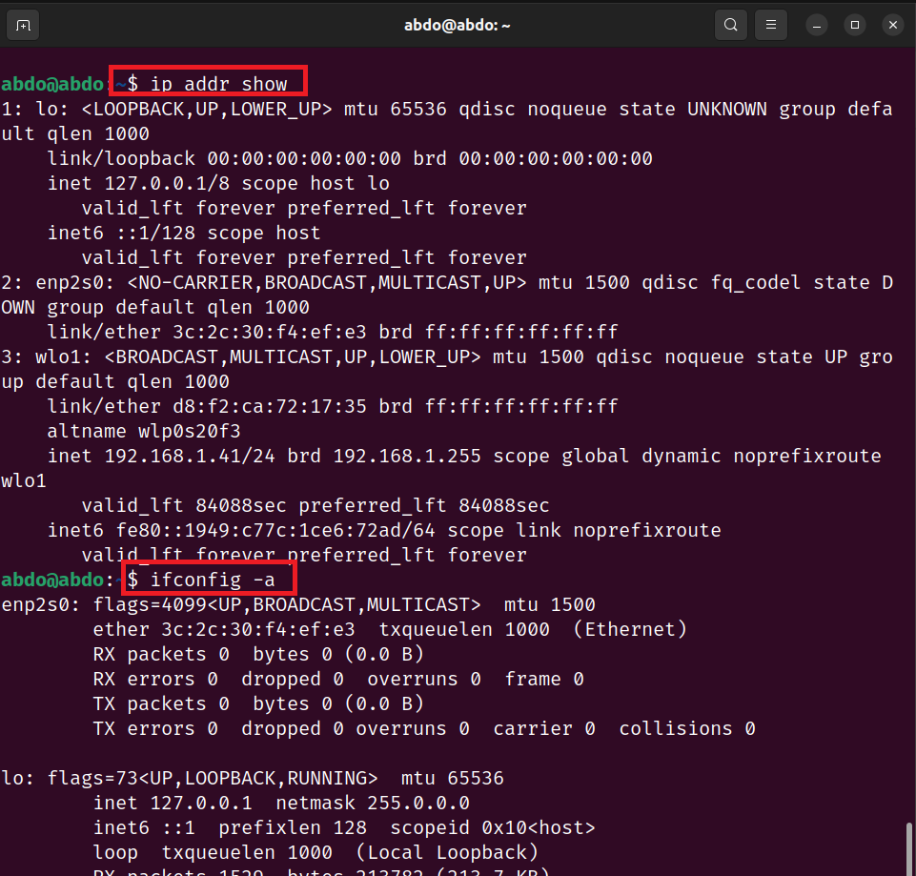

20. Bring your interface down.
21. Configure your network card to have static IP.
22. Bring your interface up.
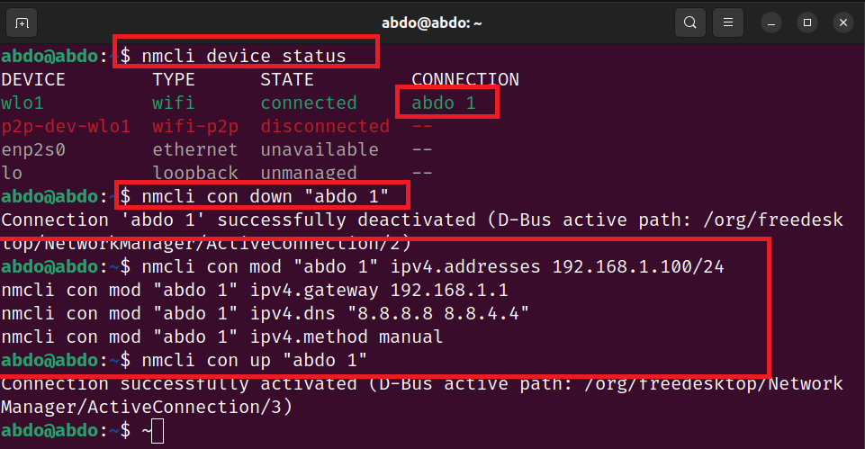

23. Verify your network setting using ifconfig command
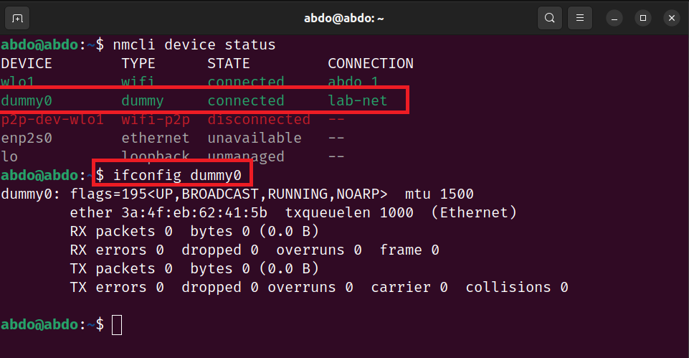

24. Configure your network card to have dynamic IP using network manager command.
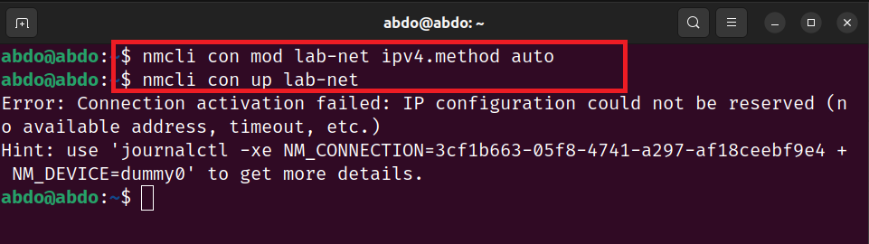

25. Check using ifconfig then check its configuration file.
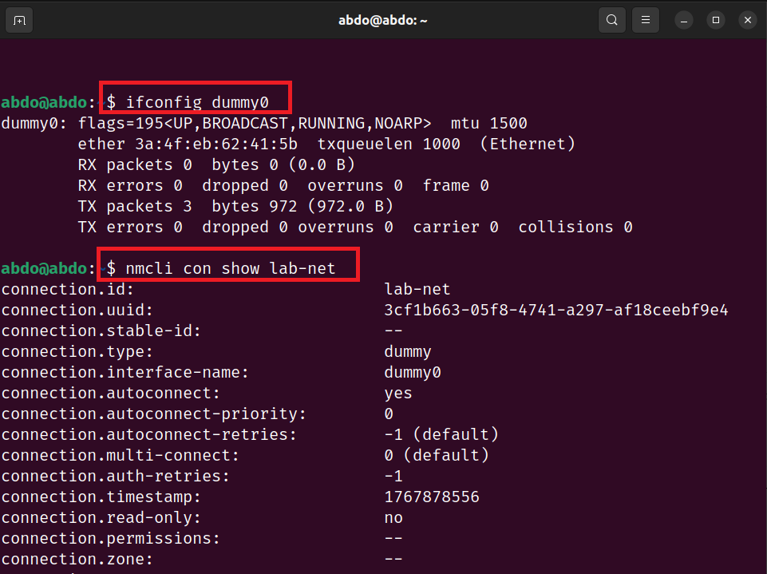

26. Reconfigure your network card using system-config-network utility to have static IP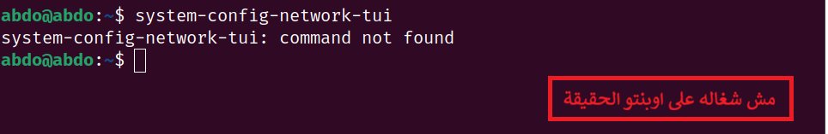

27. Configure your network card to have 3 IPs and check that they are all working using ifconfig command.
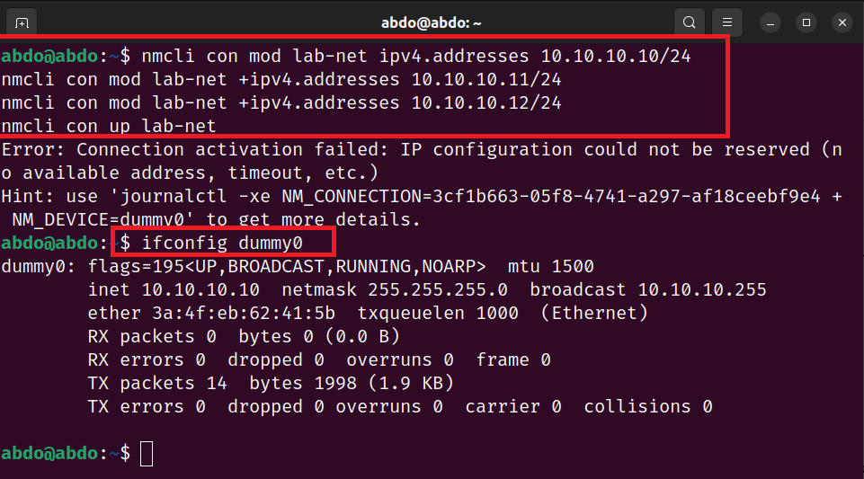

28. Change your host name in your global network file.
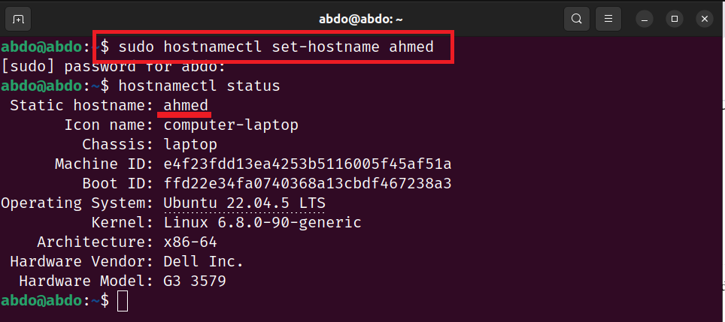

Lab2

- Change your default SELinux mode to permissive and reboot.
مش شغالين على أوبنتو الحقيقه
sudo vi /etc/selinux/config
SELINUX=enforcing → SELINUX=permissive
sudo reboot

2. After reboot, verify the system is in permissive mode.
getenforce

3. Change the default SELinux mode to enforcing.
SELINUX=enforcing

4. Change the current SELinux mode to enforcing.
sudo setenforce 1
getenforce

5. Copy /etc/resolv.conf file to root's home directory.
cp /etc/resolv.conf /root/

6. Observe the SELinux context of the intial /etc/resolv.conf
7. Move resolv.conf from root's home directory to /etc/resolv.conf
8. Observe the SELinux of the newly copied /etc/resolv.conf
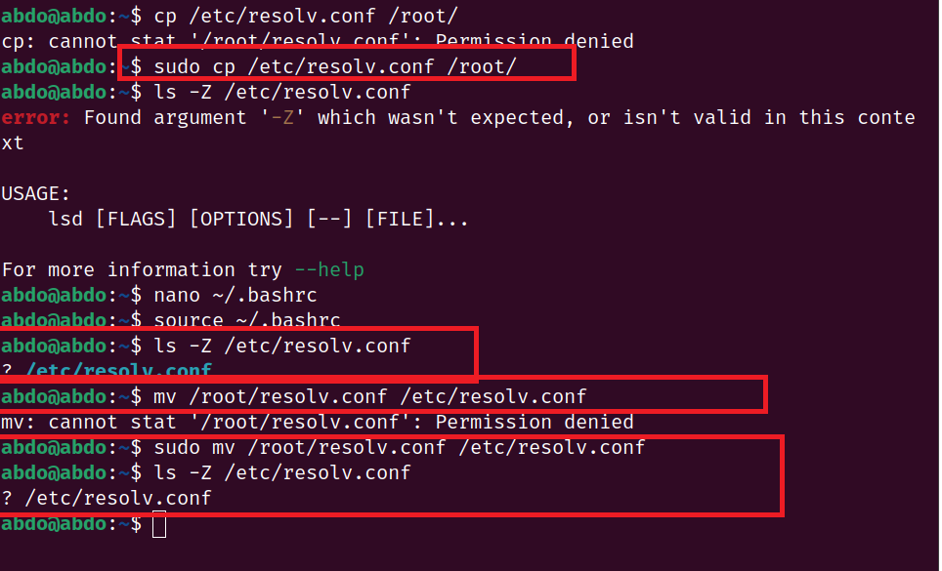

9. Restore the SELinux context of the newly positioned /etc/resolv.conf
sudo restorecon -v /etc/resolv.conf

10. Observe the SELinux context of the restored /etc/resolv.conf
ls -Z /etc/resolv.conf

